CURSILLO OUTREACH TO AMERICAN SAMOA
by Tam Nguyen, coordinator Asia Pacific Group

A team from Australia came to American Samoa to conduct the first two Cursillo for Men (24th-27th Sep 2009) and Women (29th Sep-2nd Oct 2009). 15 team members came from different states in Australia with Fr Carl Mackander as Spiritual Advisor, and Brother Peter McMahon and Sister Margaret Morris leading the teams. Brother Louis Cenac, the only team member living in American Samoa, had taken a multi-tasking role to serve in the Men’s team as well as organising the Cursillo venue, arranging team accommodation, hospitality and financial sponsorship of all the expenses occurred in American Samoa.. There were 12 candidates (new Cursillistas) who participated in the Men’s Cursillo. The men’s gathering was successfully over.

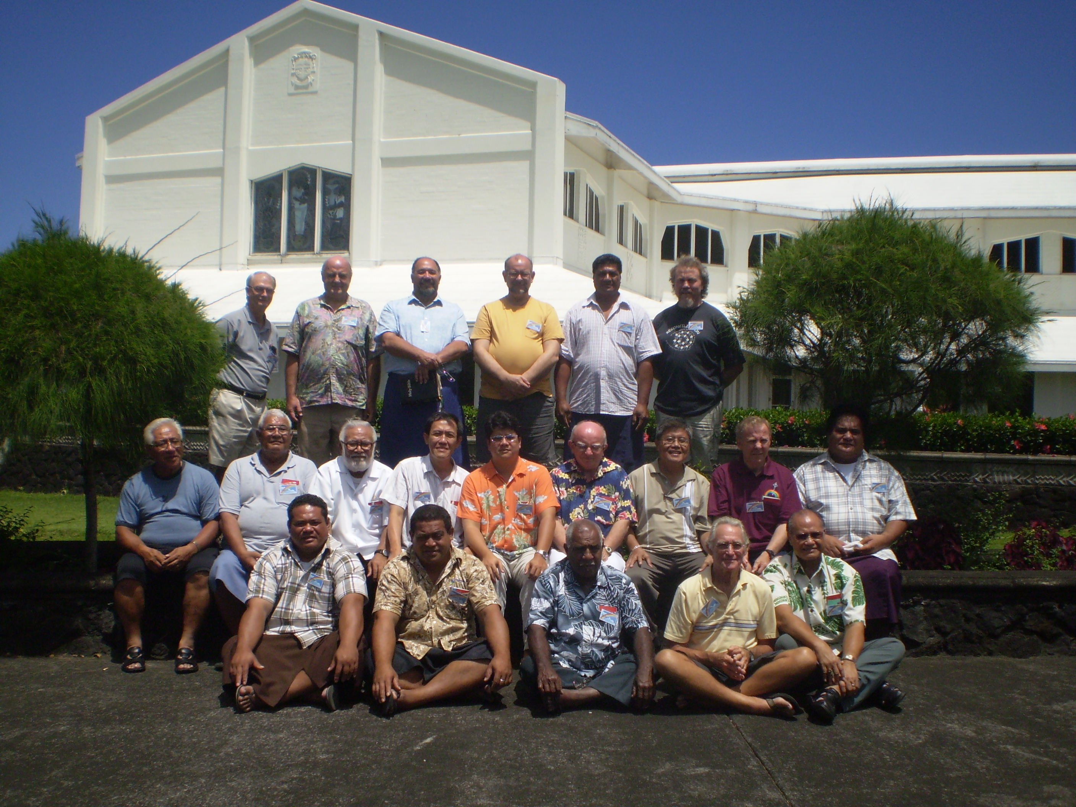

Preparations were then underway for the women's event. The Women’s Cursillo was planned to start on Tuesday 29th September, which was the day the earthquakes and Tsunami struck. With such a tragedy, those of us on the Cursillo team expected that the women's three-day retreat would most likely not go ahead. However, the Bishop advised it would be best to wait and see who turned up so the starting date was set for September 30. Four women came and so, amidst great sadness and hardship, Samoa's first women's Cursillo community was formed.

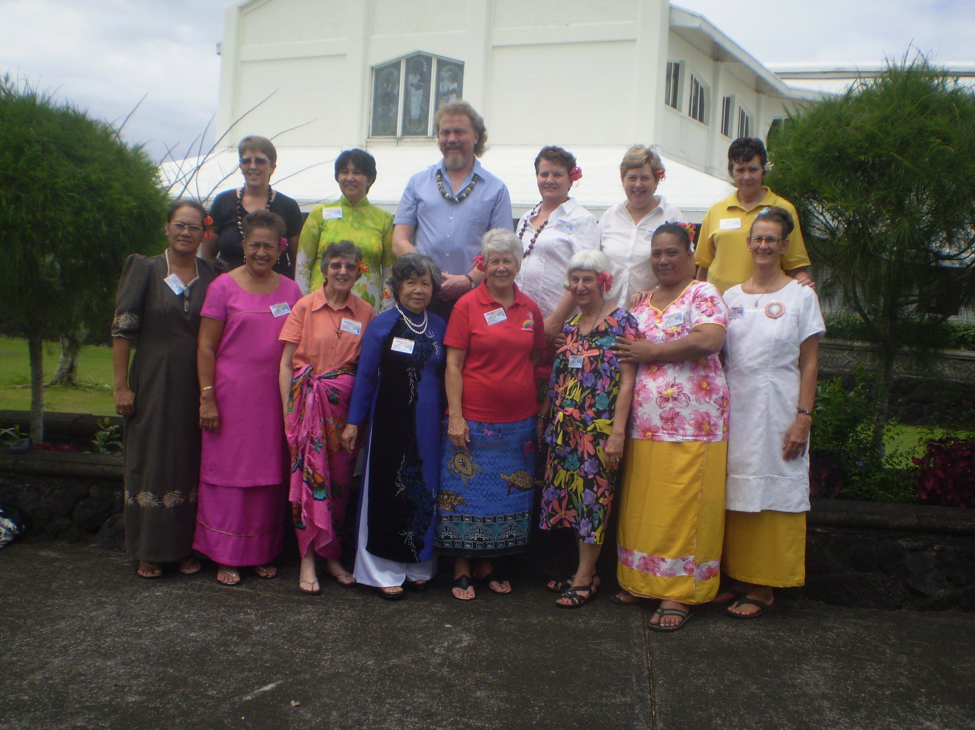

Bishop John Quinn Weitzel attended both Clausuras for Men and Women. In the Clausuras, every new Cursillista expressed their thoughts and feelings and their thanks to God for their experience over the three days. While listening, I could notice the joy, hope and content reflected upon the faces of Bishop, families, friends and everyone present. We are thankful and appreciative for the positive responses to offer prayers and Palancas from all toward the Cursillos, candidates and the team, the victims and their families during the time of tragedy.

Please join in to thank God for His blessings and guidance for the first two fruitful three-day-Cursillos in American Samoa. Our prayers and support are continuously needed toward all future tasks carried out by our Brothers and Sisters in this beautiful island country. The next Women's Three Days will be held in American Samoa in July 2010

