CURSILLOS IN DURBAN (SOUTH AFRICA) REPORT
After maybe two years of corresponding with our contact in Durban – Rob Paul – who wished to bring Cursillos to South Africa, Francis Napoli had the opportunity of visiting Durban in November 2008 with a view to carrying out an on-site assessment for the introduction of the Cursillo Movement in the city.
During that visit Francis had the opportunity to see available possible sites for the holding of Cursillos, and was able to meet with a dedicated group of possible future leaders of the Movement in South Africa. He carried with him introductory letters from the Bishop of Gibraltar for the Cardinal and the Auxiliary Bishop of Durban. Although a meeting with the hierarchy was not possible due to their many commitments, nevertheless the green light was given by the Cardinal and a meeting was held with the Pastoral Committee of the Diocese of Durban. The truth is that at the beginning the atmosphere was rather cold, but once Francis explained the methodology (without giving too much away), the meeting turned into a very friendly question and answer session, and soon everyone present was completely convinced with the idea.
Francis returned to Gibraltar and contacts continued with a view to arranging possible dates for the first Cursillo. In the end it was decided that the month of June 2009 was the best option and we started to programme two Cursillos over two consecutive weekends. These finally took place from 18th to 21st June and from 25th to 28th June. A total of 33 persons took part composed of men and women, all of them committed to becoming future leaders. The reason for holding these first Cursillos on a mixed basis was in order to cut down on the cost of sending two teams all the way to Durban. Cursillos will now be held separately for men and women in future. I have to state here that all 33 candidates were brought together by Rob Paul alone, since we did not have a Pre-Cursillo team at the outset. This says a lot about the love that everyone has for Rob in Durban and the high regard everyone has for all the work he does for the Lord.
The team was composed of four members from Gibraltar and four from Ireland, which included the Spiritual Director. The following are the names of the participating team:-
John McCullen, Dan Moore, Kevin Kerr, Fr. Beagon (Ireland); Jose Yeo, Louis Lombard, Eric Goldwin and Francis Napoli (Gibraltar).
Our preparation started some three months ahead, and although we could not be together as a team, we nevertheless kept in very close contact with each other all the time both on the phone and via e.mail.
Needless to say, because Cursillos in Gibraltar are given in Spanish, all the rollos had to be translated into English beforehand and so was the Pilgrim´s Guide. The translation of the latter was sent to Rob Paul via e.mail and printed in Durban under their own logo.
The two sides of the team arrived in Durban on 16th June in separate flights after a 13 hour journey and we were housed at the Durban Pastoral centre for the first two nights prior to the Cursillos taking place. On Thursday 18th June we travelled about 2 hours inland to a camp very appropriately named “Living Waters”. The first impression of the camp was not very positive since it is a very spacious valley and everything is quite apart – dormitories; ablutions; dinning-room; conference room; chapel etc. However, the team soon got to grips with the situation and accepted the challenge with great resolve. Men were housed on one side and the ladies on the other, with the dinning-room and conference room in the middle.

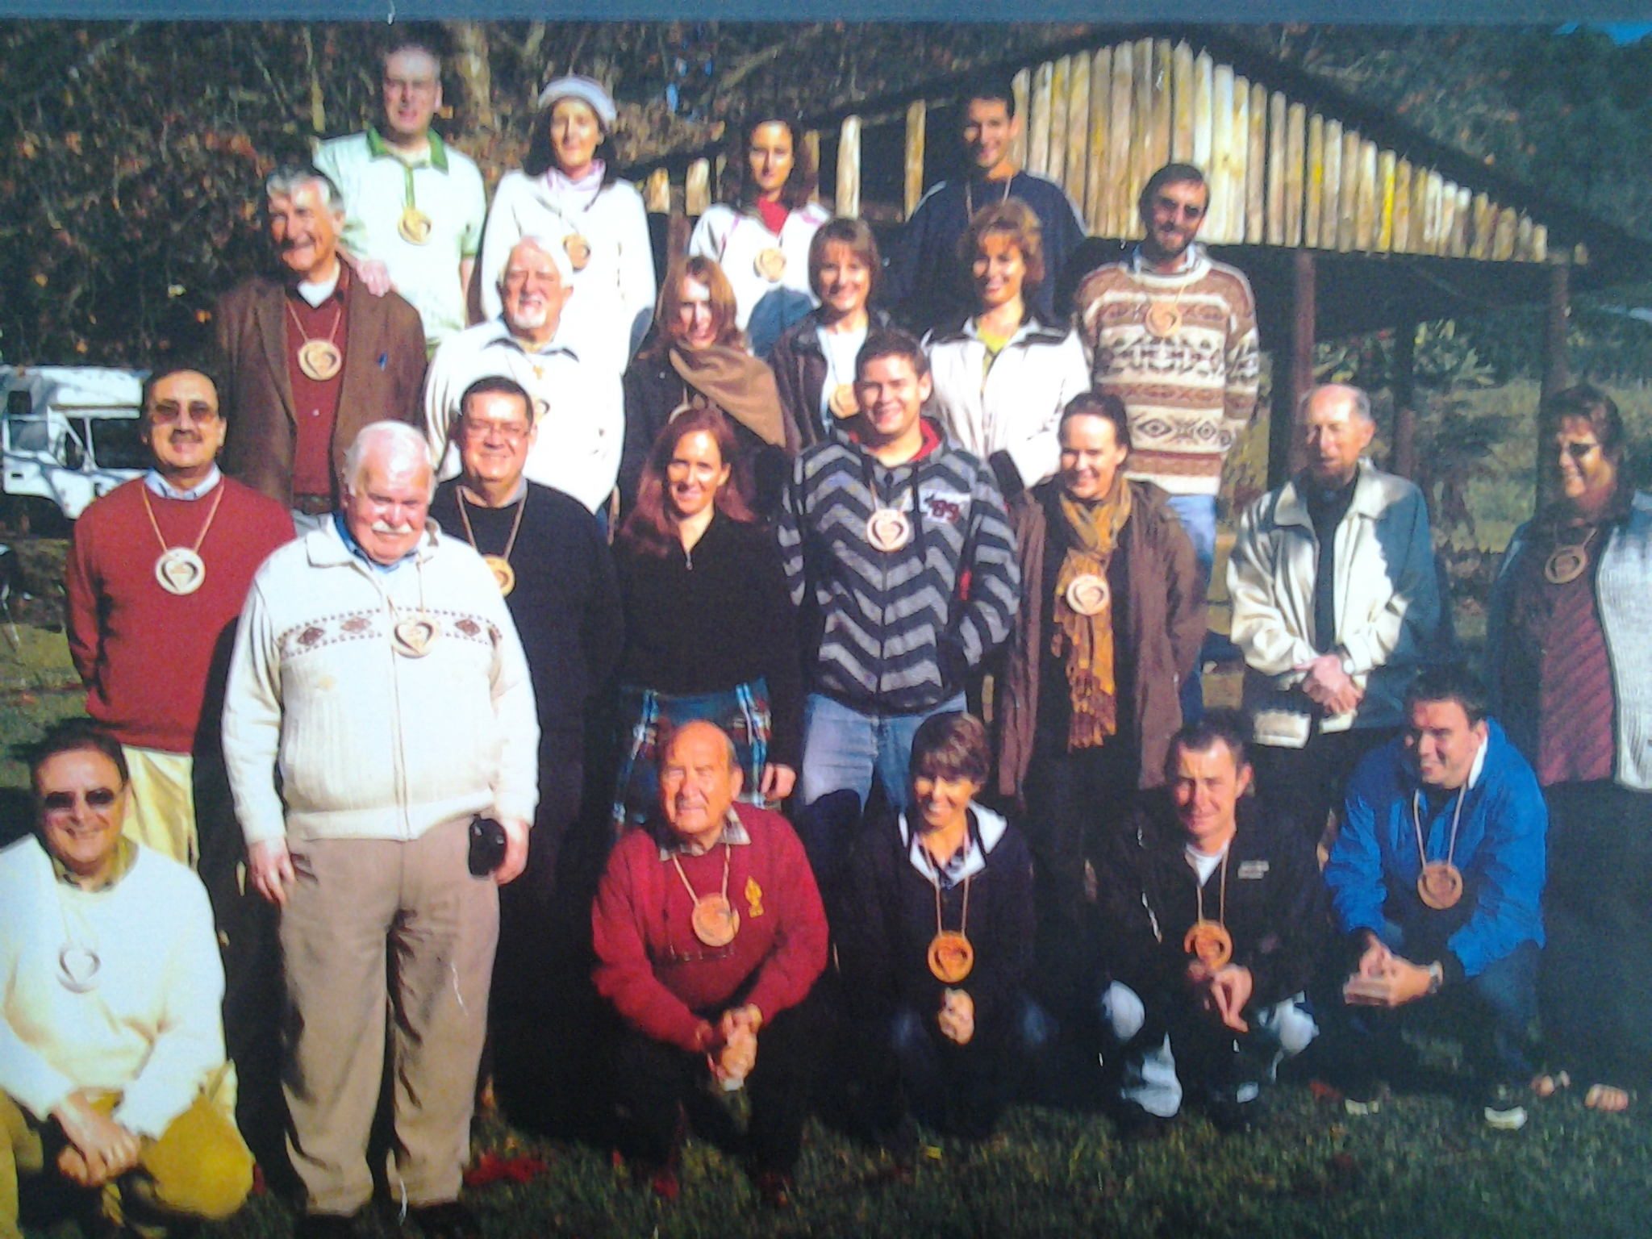

The room reserved as chapel was set up in no time and so were the group tables and chairs in the very large barn which had been converted into a conference room. We then waited eagerly for the candidates to arrive. This they did in stages, bringing with them their own bedding etc. The first Cursillo was underway and what an experience it was!
Everyone came with a hunger to live the experience and they were certainly like sponges every moment of the Cursillo. Some had travelled as much as 8 hours from Johannesburg or even further away from Cape Town. The atmosphere was tremendous from the word go and this could be seen in the summaries and posters, which were all excellent. The friendship and love shared was tremendous at all times and even the jokes told by the team were a great success! As always we could see the change in people´s faces day-by-day and also their complete surrender to the Cursillo. On this first Cursillo we did not have a closing ceremony, other than carrying out one big Group Reunion, where each candidate was asked to say why they had come to the Cursillo; what they had experienced; and what they planned to do once they left. Needless to say, all testimonies were fantastic, and this gave the team a great sense of achievement.
We rested for three days at the Pastoral Centre once again before heading back to “Living Waters” for Cursillo Nº 2. This time two of the candidates from the 1st Cursillo were added to the team as auxiliaries to gather experience – Rob and Attilla. It was as if they had lived many Cursillos, because they grasped everything with such ease and with such happiness in their faces! The weather in this 2nd one was very cold and it was the first time that many of us had experienced giving rollos with the candidates warming themselves with blankets, some wearing hats and gloves in the middle of the conference room – certainly the Gibraltarians were freezing!
The 2nd Cursillo itself was another complete success and this time we held a closing ceremony in the company of some of the candidates from the 1st.
On the Sunday morning we were advised by the management of the camp that a group of some 200 children suffering from HIV were arriving that day and that they needed to make use of the conference room after lunch.
No problem – soon after “Cursillista beyond Cursillo” was given, in no time we moved everything from the conference room to the dinning–room where Group and Ultreya was given, and then the candidates of the 1st joined us for the closing ceremony. Once again the testimonies were excellent and there was a real festivity at the end just before we said good-bye. By the way, the ladies from the first Cursillo had baked a De Colores cake which we had for dessert on Sunday. They had also adorned the chapel with flowers, and so was the dinning-room with flowers and balloons, secretly done before we arrived for lunch.
Again we left for Durban and the Pastoral Centre and the following day we were treated to a visit to a nature reserve. In the evening Rob Paul and his wife invited the team out for dinner, and to our great surprise, when we arrived at the restaurant, most of the candidates were already there and gave us a huge surprise! We sang De Colores of course and everyone in the restaurant was delighted with the apparent spirit of friendship among us.
Tuesday morning was spent with Rob and his lovely wife Nadine, setting up the structure for both the Ultreya and the School of Leaders. The National Secretariat was also established under the chairmanship of Rob Paul, and the Auxiliary Bishop accepted the nomination to become the first Spiritual Director of the South Africa Cursillo Movement at a meeting attended by Francis with him later on that day.

The members of the Diocesan Secretariat were also nominated and have been informed since our departure.
Speaking of departures, when we had checked in for our flights, and as we approached the entrance to the departure lounge, there appeared around the corner of a shop, all the cursillistas singing De Colores in Spanish! This was certainly one of the highlights of the time we spent in Durban and a real close moment to Jesus! We all joined in and sang together and when we finished, everyone at the airport started to cheer us and clapped their hands in appreciation of the song.
I will end by saying that an Ultreya is now being held every other Thursday in Durban and they have already programmed their first Cursillo as leaders for the 28th February 2010. A second Cursillo is also being set up for April in Johannesburg. With God´s help I am sure it will spread throughout South Africa in no time. I will finish off by saying that all the rollos are in the process of being translated into the Zulu language in order to access all the non-English speaking population. May God bless them always.

