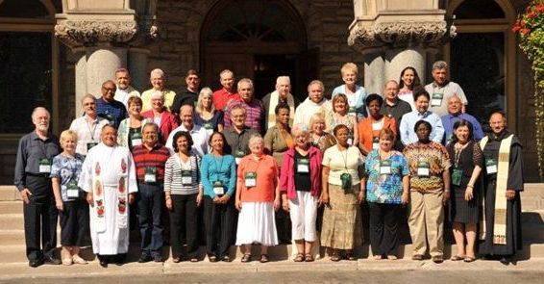
NACG ENCOUNTER
August 19-22, 2012

Our North America Caribbean Group (NACG) held an Encounter August 19–22, 2012. The goal of the encounter was friendship and the charism of the movement. All participants came together with our common bond in the Cursillo experience. We quickly became friends in an atmosphere of welcoming, love and friendship. It was Divine Providence that our meeting days were exactly the same days of the first Cursillo held in Cala Figura, Mallorca, Spain in 1944 and throughout the encounter, we felt the intercession of Eduardo Bonnin.

With the Encounter being held in Niagara Falls, Canada, we had the opportunity to visit this natural wonder. We took pictures, laughed and shared the beauty and wonder of God’s creation. There was a double rainbow over the falls to make our pictures even more beautiful. The time mirrored the theme of the 2nd World Congress in Rome – “The Beauty of Being a Christian and the Joy of Communicating it!”

Our Encounter consisted of three presentations: “The Pontifical Council for the Laity and the Charism”; “Evangelization through Conversion”, and a witness on “Friendship”. A study book was published for all who attended. The book entitled, “Study of the Charism II: Source Documents”, contains selected presentations from the four gatherings of the Pontifical Council for the Laity on Movements in the Church. Through the writings of Blessed John Paul II and Pope Benedict XVI, the importance of Movements in the Church is emphasized as they refer to Movements as the “providential response” for our times. The Holy Fathers also explain the importance of the charism and point the way to discover the charism through the movement’s founder. Our Holy Mother Church is counting on movements to know, and live their charism.

“Evangelization through Conversion” was a summary of Eduardo Bonnin’s presentation explaining how we are all on a continual conversion and how the Cursillo method of sharing in our friendship group reunions and Ultreya aids this conversion. Lastly, in “Friendship”, the importance of friendship in our Cursillo structures including NACG and the World Cursillo Movement was witnessed. With God’s Grace, friendship was the outcome of our encounter.

Our NACG feels enlivened and reconnected through our friendships with the countries in attendance. We also feel re-invigorated in studying the Charism of our Movement. We no longer look at our NACG as a “structure” or a means to an end. We now see faces of our friends! And we know that together we are strengthened in our Christian life.

Thank you Lord for the many Graces poured out on us.
Thank you each and every cursillista for your prayers, sacrifices and friendship in the Cursillo movement. Christ is counting on us, and we are counting on Christ!!

DeColores!!
NACG Executive Committee:
Gail Terrana, Fr. Einer Ochoa, Adolfo “Doc” Alvarez, Maribel Gomez and Carol Palesh

