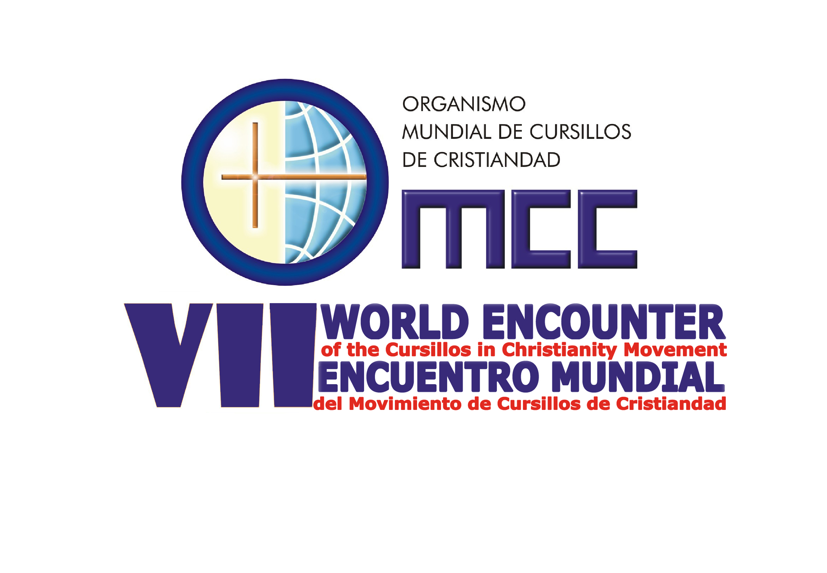

THEME: FRIENDSHIP – THROUGH HIM, WITH HIM, AND IN HIM -

THE HEART OF THE CHARISM.

VII WORLD ENCOUNTER INFORMATION

Date: 20th-24th NOVEMBER 2013
Place: Brisbane Queensland Australia
Venue: St Leo’s College, University of Queensland, St Lucia, Brisbane
Location: 18 km from Brisbane International Airport
Transport: From Brisbane International Airport to St Leo’s will be provided
Registration fee: $50 AUD per person
Accommodation: $100 AUD per person per day
Payment: On arrival at Registration Desk
Participants: 3 delegates per National Secretariat and
Observers
Money Exchange: Available at Brisbane International Airport
Registration: From 2.30pm - Wednesday November 20th
Opening Mass: St Stephen’s Cathedral – 7.30pm Wednesday 20th November
Closing: 1.30pm Sunday - November 24th
Additional Accommodation: Available before and after the Encounter at additional cost, and by prior arrangement with St Leo’s College.

Extra activities on Sunday 24th from 2.00pm: Lone Pine Koala Sanctuary; $ 35Aud or
City Souvenir Shopping.

The registration fee covers general communication expenses, material to be handed out during the event, simultaneous translation, use of electronic equipment at the presentations, use of meeting and group work facilities, transport to & from Cathedral, Brisbane.
Full conference fee from 20-24th November, including registration, all meals and accommodation, is $450Aud

