PAN-AFRICAN CONGRESS FOR CATHOLIC LAITY
4th - 9th September 2012
"BEING WITNESSES OF JESUS CHRIST IN AFRICA TODAY"

Pope Benedict reminded the delegates attending the Pan-African Congress for Catholic Laity, that Africa is a continent of hope, and underlined the important spiritual resources of the African people: " there is love of life and family, a sense of joy and sharing and enthusiasm in living faith in the Lord". This was the message read by Mgr Piero Pioppo, Apostolic Nuncio in Cameroon.

In his homily during the Eucharistic celebration of the opening ceremony, Cardinal Stanislaw Rylko (President of the Pontifical Council for the Laity) stated that evangelisation is not a secondary activity. It is the deepest reason for the Church's existence. He went on to say that Redemtoris Missio (no.11) tells us that evangelisation is a question of faith, that it is "an accurate indicator of our faith in Christ and His love for us". That those who know Christ have a duty to proclaim him, and those who do not know Him have a right to hear that proclamation. Paul the Apostle captured this idea very well when he wrote: "For when I preach the Gospel, I cannot boast, since I am compelled to preach. Woe to me if I do not preach the Gospel" (1Cor 9:16).

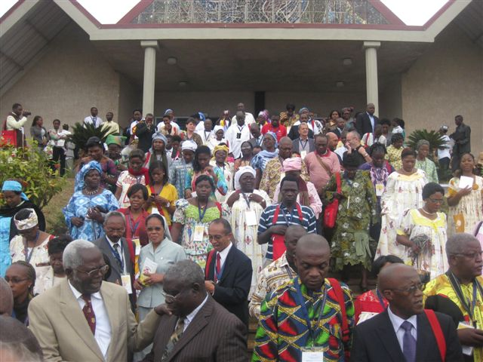

Cardinal Rylco insisted that in the evangelising mission of the Church, the lay faithful have a very important role. Because of the "secular nature" of their vocation, they are the "leavening" of the Gospel, the "salt of the earth" and "light of the world", called by Christ to transform the world from within in the light of the Gospel. Because they live in the world, that is, in each and in all of the secular professions and occupations. "What specifically characterizes the laity is their secular nature, who by their very vocation, seek the kingdom of God by engaging in temporal affairs and by ordering them according to the plan of God. They live in the world and are called there by God, that by exercising their proper function and led by the spirit of the Gospel, they may work for the sanctification of the world from within as a leaven". Africa he said, extremely needs this kind of laity as a matter of great urgency.

Archbishop Tarcisio Ziyaye of Malawi, in his speech regarding the challenges of evangelisation, encouraged the laity by emphasizing that the work of evangelisation is enormous, and that they should stand up and play their part. They should always know that they have an essential and irreplaceable role, that is, to announce and testify to Jesus Christ Himself.

Cardinal Robert Sarah (President of the Pontifical Council "Cor Unum") invited the laity of Africa to encounter Jesus Christ and His love, and to consider their formation as the first priority. He went on to say: "Encounter with Jesus and faith in Him demands lifestyles totally renewed according to the Gospel, radically transformed and transfigured by the death and resurrection of Christ". He gladly noted that this formation is already being done in many countries, although it needs to be done with more determination.

In the words of Cardinal Rylco, "The discovery of the beauty of being a Christian is a fundamental task for every lay person". "We must therefore be proud to be Christians, and be free of any inferiority complex in the non-Christian world which surrounds us. If we are not to lie when we call ourselves 'Christians', then we must bear witness to it by our way of living".

In a letter addressed to His Holiness, Pope Benedict XVI, the participants of the Congress state: "It is truly the time for us to transform Africa into a 'Continent of Hope' as you, Holy Father, expressed in the Message that you sent us. None of us will turn away from this splendid task entrusted to us by Our Lord Jesus Christ and the Holy Spirit by means of the Church".

During the Congress the OMCC delegation, consisting of Fr Maximilian Bergmayr (Spiritual Director of the GECC); Teresa Diwald (Youth leader from Austria); Robert Kpotor (Cursillo leader from Togo) and Francis Napoli (coordinator for European-African relations of the GECC), worked extremely hard and managed to have numerous meetings with heads of delegations from most countries represented. These ranged from meetings with Cardinals and Bishops, to lay members of the various Episcopal Conferences in Africa. In all instances the idea of introducing Cursillos in their country was met with great enthusiasm. Francis Napoli has been invited to make a presentation of Cursillos in Christianity at the forthcoming Bishops' Conference in November 2012 in Nairobi, Kenya. Invitations to introduce Cursillos are expected shortly from countries such as Ghana, Uganda, Zambia, Zimbabwe, Ethiopia, Nigeria and Mauritius (Francis Napoli is awaiting a date for a meeting from Cardinal Jean Margeot in Rose-Hill) . The latter are all English-speaking countries, whilst the francophone countries such as Lesotho, Mali, Madagascar, Chad, Congo and others also showed great interest to Robert Kpotor in their home language.

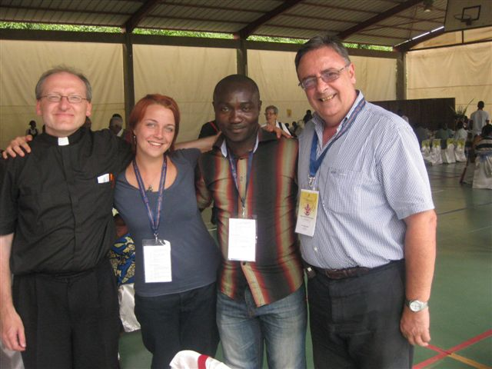

A fruitful meeting was held between the Archbishop of Yaounde, Francis Napoli and Robert Kpotor, during which Francis gave a small presentation of Cursillos. Permission was given for Cursillos to commence in Cameroon with immediate effect, with His Grace already identifying the location where these should take place and which is known to both Francis and Robert.

I must mention that Fr Mathew Mpundamwanja from the Diocese of Idete in Tanzania was living his Cursillo in Johannesburg from 6th to 9th September and that we are very hopeful that we can start Cursillos in that country in early 2013. Contact still needs to be established with the Bishop of Dar es Salaam when Fr Mathew is back home. Our friends from South Africa have taken good care of him during his stay in the Country.

Cardinal Stanislaw Rylko called us all to a great challenge - the evangelisation of Africa. Are we really up to it dear friends and brothers and sisters in Christ? It is everyone's responsibility as disciples and soldiers of Christ that we are. It is no use just sitting back and holding on to the one coin we have been given. We must go out and multiply our efforts to Christianize the environments. The world is changing faster than we would all like and we need to act now if we are not to "miss the boat" in our quest to evangelize those environments. The opportunity is here now in Africa - we have made all the right contacts and the doors are open for us to introduce our beloved Movement in each country over a period of time, with the proper coordination.

