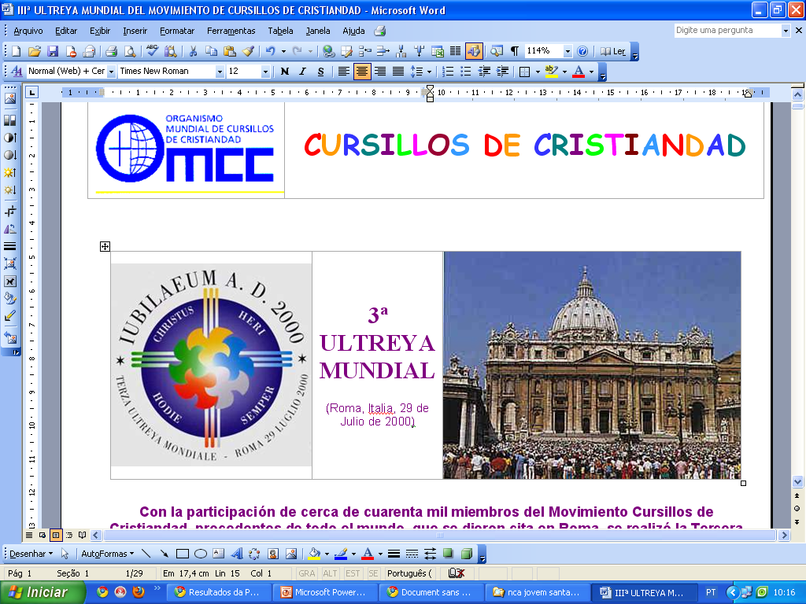
JUBILEE ULTREYA OF CURSILLO IN CRISTIANDAD
DISCOURSE OF JOHN PAUL II
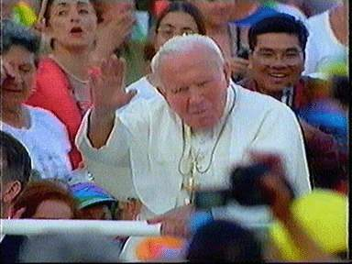

1. I am pleased to address my affectionate greeting to all of you gathered here from all five continents for the third meeting of Cursillo in Christianity, the Great Jubilee of the Ultreya. Thank you for your visit and all are welcome.
Cursilhistas I greet the Spanish-speaking, coming from America and Spain, recalling that it was in Palma that was born this apostolic experience, initiated by Msgr. Juan Hervas, zealous pastor of this church community.
I give you welcome and encourage you to do this Ultreya the Jubilee a time of renewed commitment to holiness of life and apostolate. I extend a cordial welcome to all participants of the French language. Then drive with all my heart a salute to those who have come from German-speaking countries. May this celebration strengthen your faith.
I welcome the President of the World Organization of the Cursillo in Christianity and I thank him for his cordial words to me on your behalf, presenting the apostolic commitment of your movement and the good that the Lord works through you. I greet the founders and spiritual leaders, as well as the leaders of the Movement. Your presence here, so varied and festive, shows that the tiny seed planted in Spain for over fifty years, become a tree laden with fruits of the Spirit. Moreover, it continues to be a successful response to the question asked by my venerable Predecessor, Pope Paul VI, the first world Ultreya in Rome: "The Gospel still win over the mature person ... in urban and rural ? (AAS 58 [1966], pp. 503).
Therefore, I join with joy to your thanksgiving to the Lord for everything He has done and is continuing to perform in the Church through the Cursillo in Christianity. The theme of this world Ultreya "Evangelizing the environments of the Third Millennium: a challenge for Cursillo in Christianity" witness the effort to propose again with renewed enthusiasm tools and the experience of Christ to men and women of the century. This becomes even more urgent, since "whole countries and nations, where once religion and Christian life were flourishing and capable of giving rise to communities of faith alive and industrious, are now put to the test, and sometimes until they are radically transformed by the continuing spread of indifference, secularism and atheism "(Christifideles Laici, 34).
2. Facing this situation, which challenges believers to "remake ... the Christian fabric of human society" (ibid.), the Cursillo method aims to contribute to change in a Christian way the environments where people live and work through the insertion of "new men" so transformed by the encounter with Christ. It is for this purpose that the three-day "little course" on Christianity, during which a group of priests and laity, supported by prayer and sacrifices of others belonging to the Movement, communicates the fundamental truths of the Christian faith especially the "living" way. The proclamation of Christ as proposed, almost always opens participants in Cursillo for the gift of conversion and to a deeper awareness and received the Baptism in the Church's own mission. They feel called to be "leaven" prophetic, which is kneaded with flour for baking entirely (cf. Mt 13, 33), as "salt of the earth" and "light the world" (Ibid., 5, 13 -14) to announce the people you meet, there is only salvation in Jesus Christ (Acts 4, 12), and that "the mystery of man truly becomes clear only in the mystery of the Incarnate Word" (Gaudium et Spes, 22).
3. Dear brothers and sisters, be courageous witnesses of the "service of truth" and work ceaselessly with the "power of communion." Relying on your rich spiritual experiences, which are a treasure, take the "challenge" that our time has the new evangelization, facing it without fear. Faced with a culture that often denies the very existence of an objective Truth of universal value and frequently loses the "quicksand" of nihilism (cf. Fides et Ratio, 5), the faithful should know clearly that Christ is the Way, Truth and the Life (cf. Jn 14, 6).
Jesus, whom you opened your hearts with generosity, asks you to proclaim his name untiringly to those who do not yet know. He calls you to his service in the service of truth that sets us free.
The more transparent this "Diakonia of truth" becomes in your daily lives, the more convincing it will be. As you are reminded in prayer that often used in the Cursillo Movement, "Christ has no hands, he has only our hands to change the world today. Christ has no feet, he has only our feet to guide the world to himself Christ has no lips, he has only our lips to speak to the man. "
4. This is your ministry. Take him out in constant harmony with the Church, so that show the "power of communion" which is the style and the very essence of the People of God. Given the various forms of individualism, which fragment and divide the capacity and resources evangelists, join your missionary efforts of the various ecclesial groups raised by the Spirit in the Church of our time. Strive to excel again the beauty of the first Christian communities, which prompted pagans to say with admiration: "See how they love each other." And thirst always attentive to the particulars of the Magisterium. Indeed, no charism can dispense with reference and submission to the Pastors of the Church, whose discernment is a guarantee of fidelity to their charism. This jubilee celebration instill in all of you a renewed fidelity to your original inspiration and a firmer ecclesial communion.
5. "In color, the color coat to the fields in spring.
Colors, colors the little birds come out.
Color, color is the rainbow we see shining ...".
During the days of Cursillo, the words of this popular Spanish song help participants reflect on the multifaceted beauty of creation. Finding Christ, you have learned to look with new eyes people and nature, daily events and life in general.
You have experienced that in following the Lord we achieve true happiness. This personal and community experience must be transmitted to the next. Many men and women of our time, who unfortunately turn away from God, expect from you the light of faith that will help them rediscover the colors of life and the happiness of feeling loved by God.
"Courage! Ultreya! Onward!" He repeats to you today the Successor of Peter. Look to Mary, an example of unswerving loyalty to God and, like her, in every circumstance put your trust in God, Father of mercy, which guides your steps along the path of truth and love.
To the pilgrims from Fatima to two months of the beatification of Francisco and Jacinta Marto
My greeting is extended with the same courtesy to all other pilgrims gathered here. Particularly those of the Diocese of Leiria-Fatima, led by their Bishop, the esteemed D. Serafim.
Dear Brothers and Sisters, it's been two months since I had the joy to find myself among you, enjoying your warm hospitality and of witnessing the joy of your radiant holiness confirmation of your countrymen in two: the Blessed Francisco and Jacinta Marto. Today, you voted on behalf of that local church see reciprocated the visit: to you who have come near the tomb of the Prince of the Apostles, in a spirit of prayer and penance, begging forgiveness and indulgence, and renew your dedication to that work of divinizing humanity that began two thousand years ago with the birth of God-man.
Whole-hearted welcome to the Diocese of Leiria-Fatima, with hope that this Great Jubilee of the Incarnation will prove to you all that "year of favor from the Lord," which became a reality with Jesus and Jesus (cf. Lk 4, 19 -21), that you may confidently expect the strength of his message and work of salvation, love everyone with the love of giving and also repair the ingratitude of so many people to God and to witness their faith with courage and consistency in today's society.
The Blessed Virgin, mystically present in your Marian shrines, among which stands out for its choice of the Fatima maternalmene follow your path of penance and conversion, and support you in achieving your resolutions for the good of your Diocese and for the salvation the world.
Greetings to the faithful Polish
I cordially greet you, the Polish pilgrims who have come to this meeting. I appreciate your commitment to the new evangelization and the building of the civilization of love and solidarity throughout the world. The Church needs you! Needs your Christian attitude and holiness, so that the world can accomplish the great work of salvation.
With affection, I assure you a constant remembrance in prayer and all impart the Apostolic Blessing, provider of an abundance of divine graces.

John Paul II
Castel Gandolfo, 29 July 2000.
vídeo: http://cursillos.ca/es/nouvelles/albumphoto/jp2-ultreya3.htm

